Mocap Music Second Trimester Santiago Escobar 9A

Song#1

Blinding Lights:

Name of the song: Blinding lights

Key: C# using aspects from the relative minor, A#

BPM: 171

Signature: 4/4

Artist: The Weekend

Writters: The Weekend, Max Martin & Oscar Holter

Lyrics:

[Intro]
Yeah
[Verse 1]
I've been tryna call
I've been on my own for long enough
Maybe you can show me how to love, maybe
I'm going through withdrawals
You don't even have to do too much
You can turn me on with just a touch, baby
[Pre-Chorus]
I look around and
Sin City's cold and empty (Oh)
No one's around to judge me (Oh)
I can't see clearly when you're gone
[Chorus]
I said, ooh, I'm blinded by the lights
No, I can't sleep until I feel your touch
I said, ooh, I'm drowning in the night
Oh, when I'm like this, you're the one I trust
Hey, hey, hey
[Verse 2]
I'm running out of time
'Cause I can see the sun light up the sky
So I hit the road in overdrive, baby, oh
[Pre-Chorus]
The city's cold and empty (Oh)
No one's around to judge me (Oh)
I can't see clearly when you're gone

[Chorus]
I said, ooh, I'm blinded by the lights
No, I can't sleep until I feel your touch
I said, ooh, I'm drowning in the night
Oh, when I'm like this, you're the one I trust

[Bridge]
I'm just calling back to let you know (Back to let you know)
I could never say it on the phone (Say it on the phone)
Will never let you go this time (Ooh)

[Chorus]
I said, ooh, I'm blinded by the lights
No, I can't sleep until I feel your touch
Hey, hey, hey
Hey, hey, hey

[Outro]
I said, ooh, I'm blinded by the lights
No, I can't sleep until I feel your touch

Genre:
- Synthwave.
- synth-pop.
- Electropop

Instruments:

- Piano
- Guitar

Chords:
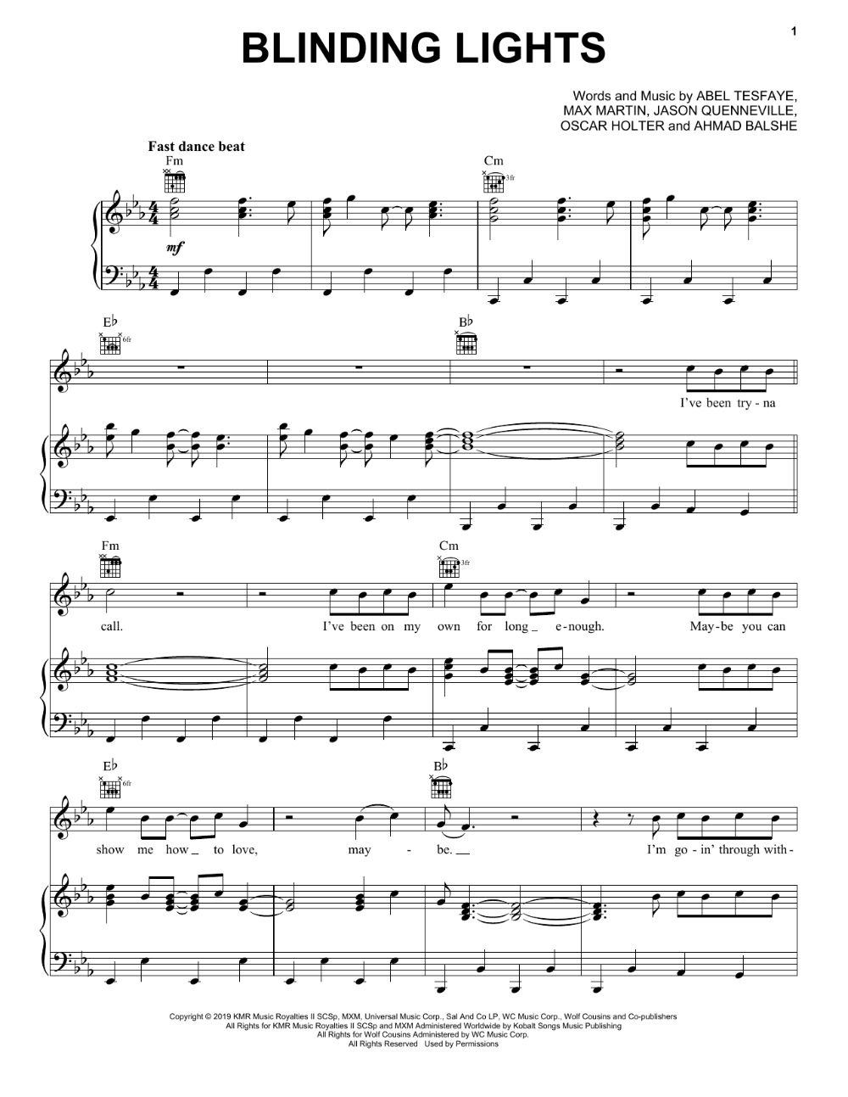

Song#2

Stressed Out

Name of the song: Stresed out

Artist/Group/Duo: Twenty one Pilots
Key: A Minor

BPM: 86

Signature: 4/4

Writter: Tyler Joseph

produced by: Mike Elizondo

Lyrics
[Verse 1]
I wish I found some better sounds no one's ever heard
I wish I had a better voice that sang some better words
I wish I found some chords in an order that is new
I wish I didn't have to rhyme every time I sang
I was told, when I get older, all my fears would shrink
But now I'm insecure, an' I care what people think

[Pre-Chorus]
My name's Blurryface and I care what you think
My name's Blurryface and I care what you think

[Chorus]
Wish we could turn back time to the good old days
When our momma sang us to sleep, but now we're stressed out
(Oh) Wish we could turn back time (Oh) to the good old days (Oh)
When our momma sang us to sleep, but now we're stressed out
We're stressed out

[Verse 2]
Sometimes a certain smell will take me back to when I was young
How come I'm never able to identify where it's comin' from?
I'd make a candle out of it, if I ever found it
Try to sell it, never sell out of it, I'd probably only sell one
It'd be to my brother, 'cause we have the same nose
Same clothes, homegrown, a stone's throw from a creek we used to roam
But it would remind us of when nothing really mattered
Out of student loans and treehouse homes, we all would take the latter

[Pre-Chorus]
My-my-my name's Blurryface and I care what you think
My name's Blurryface and I care what you think
[Chorus]
Wish we could turn back time to the good old days
When our momma sang us to sleep, but now we're stressed out
(Oh) Wish we could turn back time (Oh) to the good old days (Oh)
When our momma sang us to sleep, but now we're stressed out
[Bridge]
We used to play pretend, give each other different names
We would build a rocket ship an' then we'd fly it far away
Used to dream of outer space, but now they're laughin' at our face
Sayin', "Wake up, you need to make money!," yeah
We used to play pretend, give each other different names
We would build a rocket ship an' then we'd fly it far away
Used to dream of outer space, but now they're laughin' at our face
Sayin', "Wake up, you need to make money!," yeah
[Chorus]
Wish we could turn back time to the good old days
When our momma sang us to sleep, but now we're stressed out
(Oh) Wish we could turn back time (Oh) to the good old days (Oh)
When our momma sang us to sleep, but now we're stressed out

[Outro]
We used to play pretend, used to play pretend, money
We used to play pretend, wake up, you need the money
Used to play pretend, used to play pretend, money
We used to play pretend, wake up, you need the money
Used to play pretend, give each other different names
We would build a rocket ship an' then we'd fly it far away
Used to dream of outer space, but now they're laughin' at our face
Sayin', "Wake up, you need to make money!," yeah

Genre:
Hip Hop/ Rap
Rock

Instruments:
Bb Instrument,
range: B3-D5
(Tenor Saxophone,
Trumpet,
Clarinet or
Soprano Saxophone)
Base
Drum

Chords:
